Experiment 6

1. AIM:
To design and develop an interactive Executive Dashboard and Business Scorecard using Microsoft Power BI for monitoring organizational performance, supporting business decision-making, and communicating key performance indicators (KPIs) effectively.

2. OBJECTIVE:
- To design and develop an interactive Executive Dashboard using Microsoft Power BI.
- To identify and visualize important business performance indicators such as Total Sales, Total Profit, Total Orders and Profit Margin.
- To analyse sales performance across different regions, product categories and customer segments.
- To implement interactive slicers and filters for dynamic data exploration.

3. TOOLS / SOFTWARE REQUIREMENTS
- Microsoft Power BI Desktop
- Global Superstore Dataset.xlsx
- Power Query Editor
- DAX (Data Analysis Expressions)
4. DATASET SOURCE: Global Superstore Dataset (Kaggle)

5. THEORY:
A Dashboard is a visual interface that presents important business metrics, trends, and performance indicators in a consolidated view. Dashboards help executives and managers monitor organizational performance and make informed decisions.
A Scorecard is a management tool used to compare actual performance against predefined targets. Scorecards help organizations track progress toward strategic objectives using Key Performance Indicators (KPIs).
Power BI provides a rich set of visualization tools, KPI cards, charts, slicers, filters, and interactive features that allow users to build professional dashboards and scorecards.

Business Scenario
You are working as a Business Intelligence Analyst for Global Superstore. The executive management team requires a one-page dashboard and performance scorecard to monitor sales, profit, customer growth, and operational performance. Your task is to design a professional dashboard and provide recommendations based on your findings.

6. PROCEDURE:

Part A: Dashboard Planning

Step 1: Open Power BI and load the dataset.
How to perform:
- Open Microsoft Power BI Desktop.
- Click Home → Get Data → Excel Workbook.
- Browse and select Global Superstore Dataset.xlsx.
- Select the Orders sheet/table in Navigator.
- Click Load.
- Wait for the dataset to load successfully.
- Switch to Report View
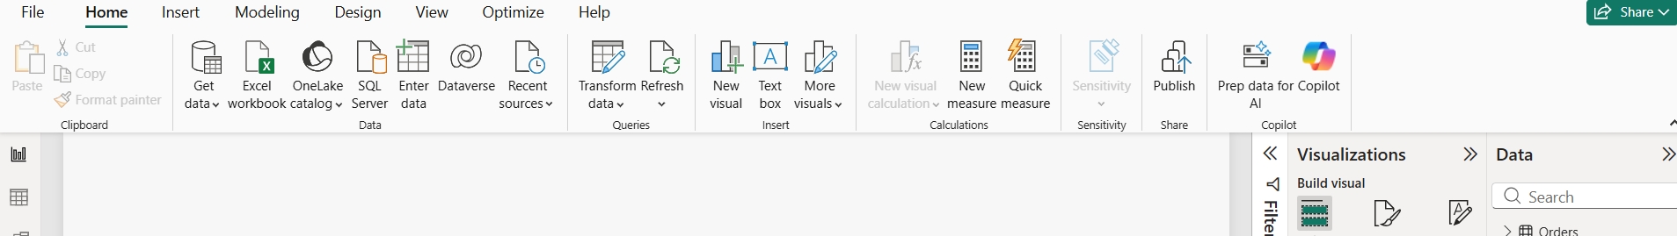
Figure 1: Global Superstore Dataset Loaded in Microsoft Power BI Desktop.

Step 2: Identify the business performance indicators.
The management team requires four important KPIs:
- Total Sales
- Total Profit
- Total Orders
- Profit Margin

These indicators will be used to monitor overall business performance.

Step 3: Create DAX measures.
Go to the Orders table → right-click → New Measure.
Create the following measures one by one.
Total Sales
Total Sales = SUM(Orders[Sales])
Total Profit
Total Profit = SUM(Orders[Profit])
Total Orders
Total Orders = DISTINCTCOUNT(Orders[Order ID])
Profit Margin
Profit Margin =
DIVIDE([Total Profit], [Total Sales], 0)

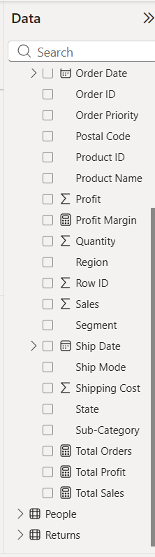

Part B: Create the Executive KPI Dashboard

Step 4: Create four KPI Cards.
How to perform:
- Open Report View.
- Select the Card visual from Visualizations.
- Drag Total Sales into the Card's Data field.
- Repeat for Total Profit, Total Orders and Profit Margin.
- Arrange all four cards in a horizontal row.
- Open Format Visual.
- Enable the visual title and set suitable titles.
- Adjust font size, display units and number formatting.

Step 5: Create Sales by Region.
How to perform:
- Select Clustered Bar Chart.
- Drag Region into the Y-axis.
- Drag Total Sales into the X-axis.
- Open the visual's Format settings.
- Enable Data Labels.
- Change the title to Total Sales by Region.
- Sort Total Sales in descending order.
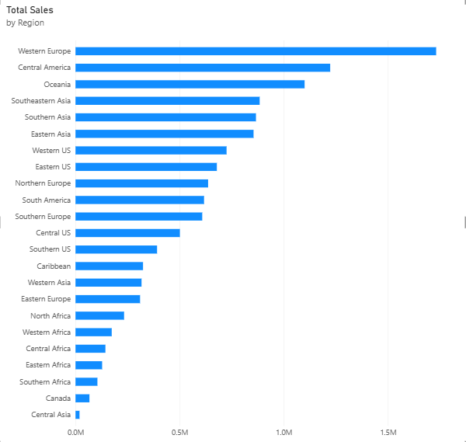

Step 6: Create Sales by Category.
How to perform:
- Select Donut Chart.
- Drag Category into Legend.
- Drag Total Sales into Values.
- Enable Detail Labels.
- Set the title to Total Sales by Category.
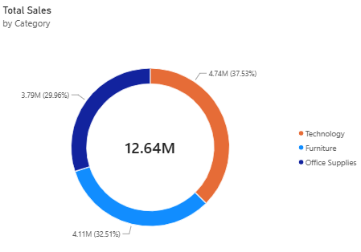

Step 7: Create Monthly Sales Trend.
How to perform:
- Select Line Chart.
- Drag Order Date into the X-axis.
- Select the Date hierarchy.
- Keep Year and Month in the hierarchy.
- Drag Total Sales into the Y-axis.
- Expand the date hierarchy to the month level if required.
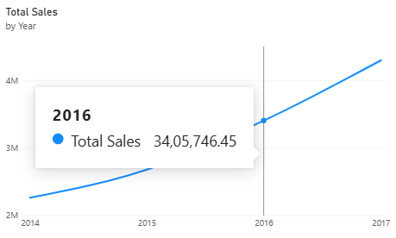

Step 8: Create Top 10 Customers by Sales.
How to perform:
- Select Clustered Bar Chart.
- Drag Customer Name into Y-axis.
- Drag Total Sales into X-axis.
- Select the visual and open the Filters pane.
- Expand Customer Name under Filters on this visual.
- Change Filter Type to Top N.
- Enter 10.
- Drag Total Sales into By Value.
- Click Apply Filter.
- Set the title to Top 10 Customers by Sales.
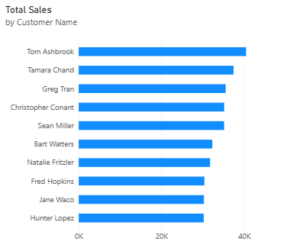

Step 9: Create Profit by Segment.
How to perform:
- Select Clustered Column Chart.
- Drag Segment into X-axis.
- Drag Total Profit into Y-axis.
- Enable Data Labels.
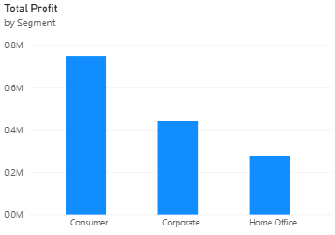

Step 10: Arrange and format the dashboard.
Arrange the four KPI cards at the top and the five charts below them.
Use consistent colours, readable titles, suitable spacing and proper number formats.
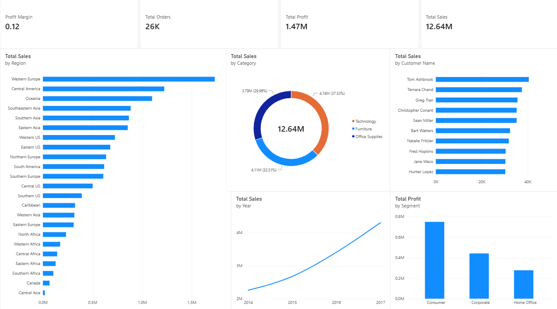

Part C: Add Interactive Features

Step 11: Add Region slicer.
- Select Slicer from Visualizations.
- Drag Region into the Field section.
- Change the slicer style to Dropdown.
- Position it at the top of the dashboard.

Step 12: Add Category and Year slicers.
Repeat the same process for:
- Category
- Year

Step 13: Configure slicer interactions.
- Select the Region slicer.
- Go to Format → Edit interactions.
- Check the interaction icons above each visual.
- Select the Filter icon for all relevant cards and charts.
- Repeat for Category and Year slicers.
- Turn off Edit interactions.

Step 14: Test dashboard interactivity.
- Select a Region from the slicer.
- Observe changes in the KPI cards and charts.
- Select a Category.
- Observe the updated values.
- Select a Year.
- Confirm the monthly sales trend changes accordingly.
- Clear all selections to restore the original dashboard.
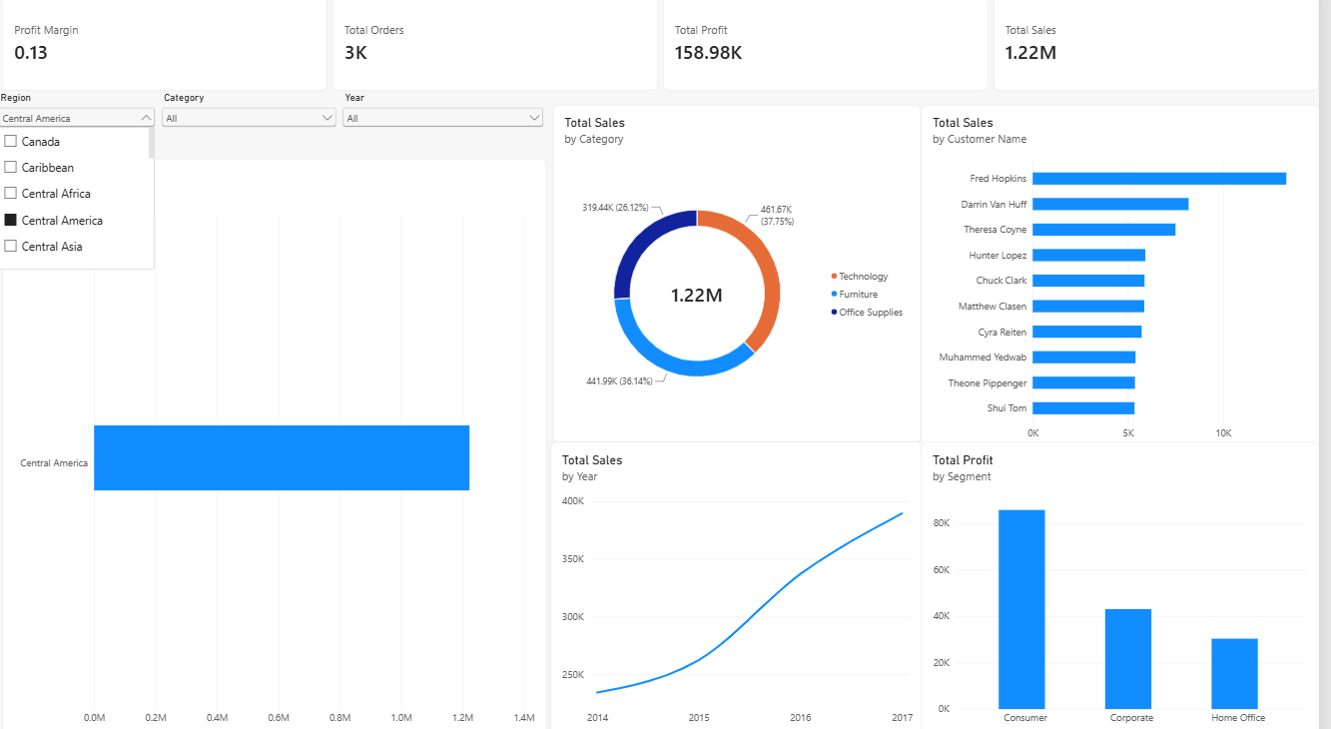
Part D: Create Business Scorecard

Step 15: Create target values.
We need predefined targets to compare against actual performance.
For demonstration, use these sample targets:

KPI | Target
Sales | 2,500,000
Profit | 300,000
Orders | 5,200
These are illustrative targets, not actual values from the dataset.
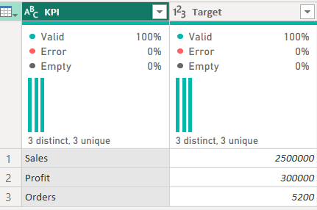

Step 16: Create Actual Performance measure.
Go to New Measure and enter:
Actual Performance =
SWITCH(
SELECTEDVALUE(KPI_Targets[KPI]),
"Sales", [Total Sales],
"Profit", [Total Profit],
"Orders", [Total Orders],
BLANK()
)

Step 17: Create Target Performance measure.
Target Performance =
SUM(KPI_Targets[Target])

Step 18: Create Achievement Percentage.
Achievement % =
DIVIDE(
[Actual Performance],
[Target Performance],
0
)

Step 19: Create Performance Status.
Performance Status =
SWITCH(
TRUE(),
[Achievement %] >= 1, "Achieved",
[Achievement %] >= 0.9, "Partially Achieved",
"Not Achieved"
)

Step 20: Create the Business Scorecard.
How to perform:
- Click the (+) button to create a new page.
- Rename it Business Scorecard.
- Select the Table visual.
- Add the following fields:
  - KPI_Targets[KPI]
  - Actual Performance
  - Target Performance
  - Achievement %
  - Performance Status
- Format the table and set the title to Business Performance Scorecard.
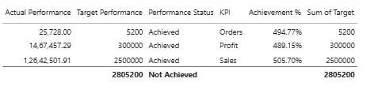

Step 21: Apply conditional formatting.
How to perform:
- Select the Business Scorecard table.
- Open Format Visual.
- Find the Performance Status column under Cell Elements or Conditional Formatting.
- Enable Background Color.
- Apply these colours:
Status | Colour
Achieved | Green
Partially Achieved | Yellow
Not Achieved | Red
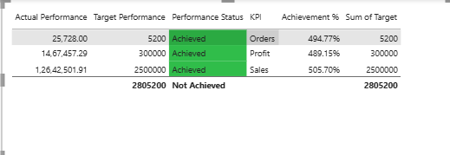
Step 22: Final Dashboard
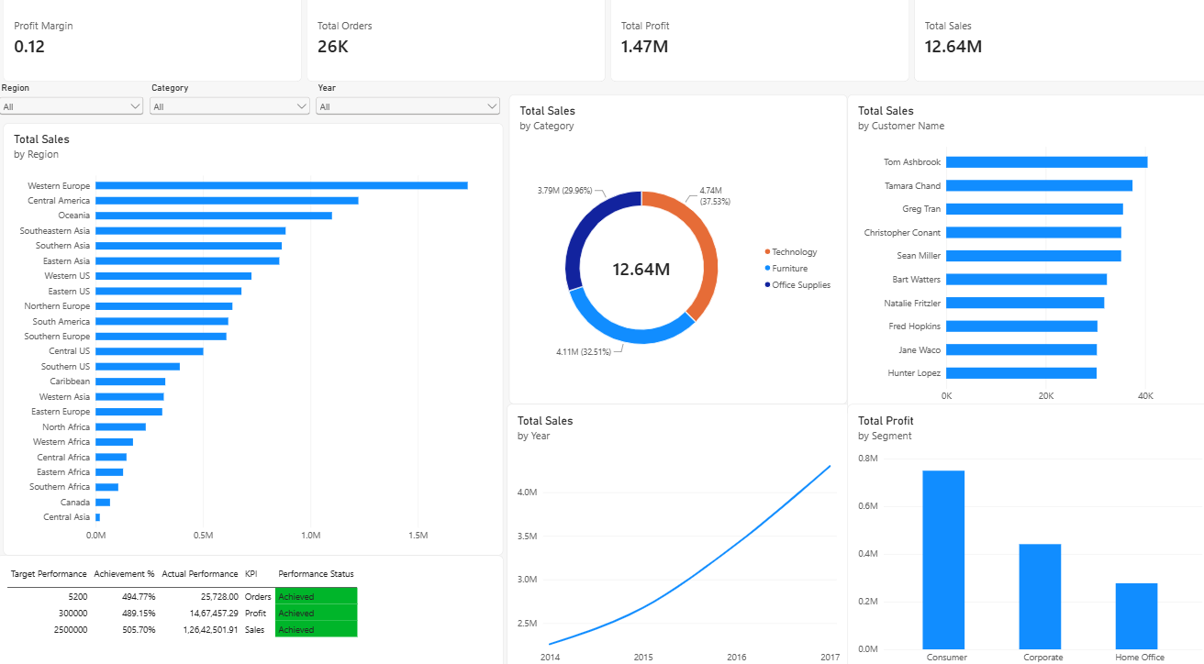

RESULT:
An interactive Executive Dashboard and Business Scorecard were successfully developed using Microsoft Power BI. Key business metrics were visualized through KPI cards, charts, and slicers, enabling performance monitoring and business analysis.

LEARNING OUTCOME:
• Design interactive dashboards using Power BI visualizations. (CO5-BT6)
• Create KPI-based scorecards for performance monitoring. (CO5-BT6)
• Apply visualization best practices in dashboard design. (CO3-BT3)
• Analyze business performance using dashboard insights. (CO3-BT4)
• Develop recommendations based on data-driven findings. (CO5-BT6)

